The Electric utility grid operates most efficiently if the connected loads do not distort or shift the current waveform. Unfortunately when AC power is converted to DC from rectification, the current is distorted, contains high frequencies, and has the appearance of low power factor due to the harmonic content. Most AC drives convert power to DC as the first part of the conversion process to variable voltage and frequency. High distortion can cause many problems and create issues with other loads connected to the grid. IEEE-519 established in 1982 (current version 2014) is a guideline for determining limits of allowable distortion that would be typically acceptable for clean power.

Yaskawa’s General Purpose MV1000 drive utilizes an integral transformer with six patented phase shifted secondaries for cancellation of the harmonics resulting from rectification. Phase shifted harmonic cancellation methods using an isolation transformer have proven to be significantly less application sensitive as compared to other methods of harmonic mitigation for rectifier harmonics.

A specially designed single transformer (US Patent 8,923,024 B2) has six phase shifted secondaries connected to individual full wave bridge rectifiers. The unique phase shift of each secondary cancels harmonic frequencies even better than 36 pulse cancellation which easily **meets the strict requirements of IEEE-519 -2014 even at the drive input**. The result is a THD that is less than 2.5% (see table below).

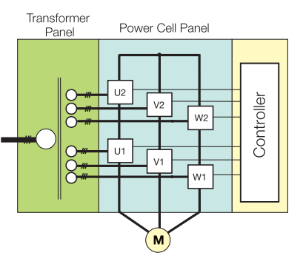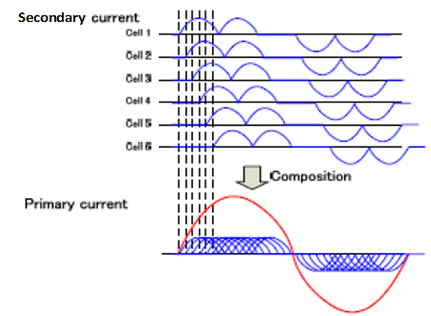



When performing electrical modeling of the utility grid, please use the following typical voltage and current distortion numbers:

|  |  |  |  |
| --- | --- | --- | --- |
| Harmonic Frequency | Harmonic Number | % Voltage | % Current |
| DC | 0 | .02 | .06 |
| 60 | 1 | 99.99 | 99.97 |
| 120 | 2 | 0.02 | 0.04 |
| 180 | 3 | 0.14 | 1.73 |
| 240 | 4 | 0.01 | 0.02 |
| 300 | 5 | 0.31 | 1.28 |
| 360 | 6 | 0.01 | 0.02 |
| 420 | 7 | 0.18 | 0.56 |
| 480 | 8 | 0.01 | 0.02 |
| 520 | 9 | 0.12 | 0.14 |
| 600 | 10 | 0.01 | 0.01 |
| 660 | 11 | 0.13 | 0.34 |
| 720 | 12 | 0.01 | 0.00 |
| 780 | 13 | 0.06 | 0.16 |
| 840 | 14 | 0.01 | 0.01 |
| 900 | 15 | 0.02 | 0.00 |
| 960 | 16 | 0.01 | 0.00 |
| 1020 | 17 | 0.02 | 0.03 |
| 1080 | 18 | 0.01 | 0.00 |
| 1140 | 19 | 0.02 | 0.04 |
| 1200 | 20 | 0.00 | 0.01 |
| 1260 | 21 | 0.01 | 0.01 |
| 1320 | 22 | 0.00 | 0.01 |
| 1380 | 23 | 0.00 | 0.00 |
| 1440 | 24 | 0.00 | 0.00 |
| 1500 | 25 | 0.01 | 0.01 |

Higher order measurements are available (all are under 0.01%)

Power factor is typically 0.95 or better. The MV1000 drive will not contribute to power line short circuit current and will not allow motor to contribute fault current. The drive is considered a linear load and is not application sensitive to existing voltage distortion. It will not ring or resonate with existing power line harmonics. When the drive is at full load, it is typically noted that overall existing voltage distortion is reduced because additional linear load is applied to the power grid.

Please contact the drive support group for application assistance or if you have additional questions: [kurt_ledoux@yaskawa.com](mailto:kurt_ledoux@yaskawa.com) [(262) 221-5178](tel:%20(262)221-5178); [Tom_Sasada@yaskawa.com](mailto:Tom_Sasada@yaskawa.com) [(847) 275-4838](tel:%20(847)275-4838)

[John_Merrison@yaskawa.com](mailto:John_Merrison@yaskawa.com) [(224) 246-0458](tel:%20(224)246-0458)